Project Development Phase– Model Performance Test  
Project - Garage Management System

**Team ID**: LTVIP2025TMID31528

College Name: Ideal Institute of Technology

**Model Performance Testing**

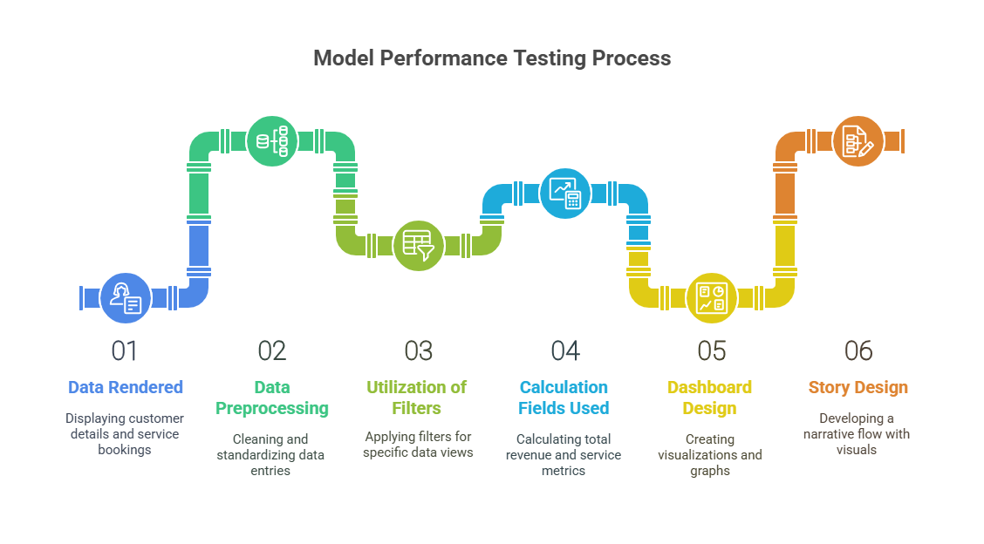The purpose of this testing phase is to assess the effectiveness and performance of the dashboard and data visualization components of the project.

| **S.No.** | **Parameter** | **Screenshot / Values / Description** |
| --- | --- | --- |
| 1 | **Data Rendered** | Customer details, service bookings, vehicle types, billing, service time |
| 2 | **Data Preprocessing** | Cleaned raw entries, removed duplicates, standardized date & time fields |
| 3 | **Utilization of Filters** | Filters used for date, service type, vehicle type, customer status |
| 4 | **Calculation Fields Used** | Total Revenue, No. of Vehicles Serviced, Avg. Service Time, Monthly Growth |
| 5 | **Dashboard Design** | **No. of Visuals/Graphs:** 6  Types: Bar chart (services/month), Pie chart (vehicle types), Line graph (revenue trend), KPI cards (revenue, service count), Filter panel |
| 6 | **Story Design** | **No. of Visuals/Graphs in Story:** 4  Narrative flow: Customer inflow → Top services → Revenue growth → Recommendations for improvements |

**Description:**

* The **Garage Management System** dashboard is designed to provide real-time insight into business performance.
* Data is collected from customer entries, service records, and billing logs.
* Calculated metrics help in understanding daily operations, peak hours, and revenue trends.
* Filters provide flexibility for specific queries (e.g., by month, service type).
* The dashboard design is clean, responsive, and easy to interpret for stakeholders.

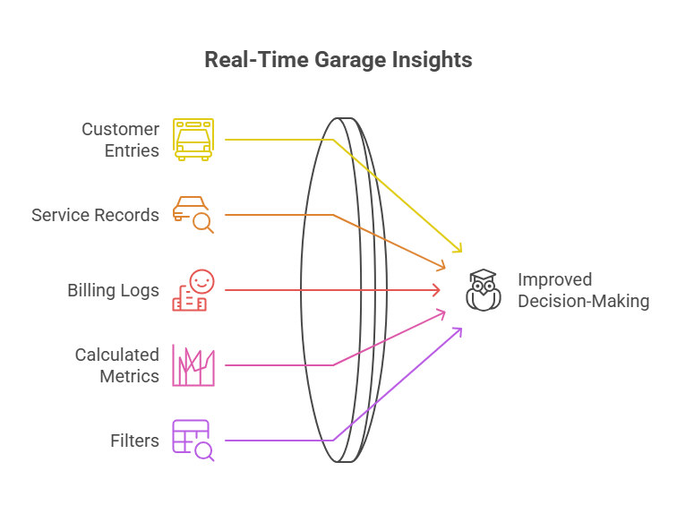

**Objective Achieved:**

Efficient visualization of key garage operations to improve decision-making, resource allocation, and customer satisfaction.